Rule Engine Status Screen

V3.0.0.59

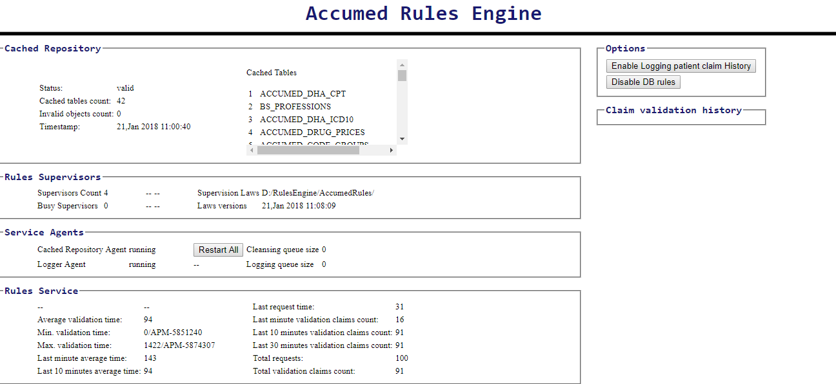

# Cached Repository

This section provides information about the cached data from ACCUMED Live DB.

|  |  |
| --- | --- |
| **Item** | **Description** |
| Status | Valid: the cached data is identical to the data in the DB.  Invalid: the cached data is different than the data in the DB.  The changed in DB will be checked periodically by rules engine, this can be controlled by:  com.accumed.rules.engine.repository.check.interval=currently is set to 30 seconds |
| Cached tables count | Number: the count of tables cached in the rules engine in-memory repository |
| Invalid objects count | Number: the count of invalid objects due to invalid data related to changed tables in the DB.  Note: multiple objects may rely on single tables. |
| Timestamp | The time when that last synchronization with the DB was done. |
| Cached tables | Lists the cached tables in the rules engine in-memory repository. |

# Rules Supervisors

|  |  |
| --- | --- |
| **Item** | **Description** |
| Supervisors count | The count of supervisors currently existed in rules engine, each supervisor has its own cached repository instance and will be disposed and re-created when any change detected in the main cached repository.  Each supervisor creation consumes about 2.5 GB of RAM. The minimum and maximum count of supervisors can be controlled by:  com.accumed.rules.engine.workers.pool.min.size: currently set to 4  com.accumed.rules.engine.workers.pool.max.size: currently set to 10 |
| Busy Supervisors | The count of busy supervisors, if another claim is sent when all the supervisors are busy a new one will be created, and this will take some time …currently about 10 to 20 seconds. |
| Supervision Laws | The directory where rules packages are being used. |
| Laws version | The version of the packages (the file date-time). |

# Service Agents

|  |  |
| --- | --- |
| **Item** | **Description** |
| Cached Repository Agent | Running/stopped  The agent who checks for DB changes compared to cached repository |
| Logger Agent | Running/stopped  The agent responsible to clean the in-memory logging of the rules engine after pre-defined period currently set to 12 hours. |
| Cleansing queue size | The number of threads working in cleansing supervisors.  After a supervisor works in validating a claim it needs to rest for a while and clean his mind ☺ this is done in a separated thread. |
| Logging queue size | The queue size of the persisting function of requests, that is the waiting requests to be saved.  The persisting of requests is done by dedicated set of threads, the number of those threads can be controlled by:  com.accumed.rules.engine.logging.threads.max.count=currently set to 2 |
| Restart all | To restart all agents… |

# Rules Service

## Options

|  |  |
| --- | --- |
| **Item** | **Description** |
| Enable Logging Patient claim history | By default: disabled  When enabled the previous claims coming with the claim being validated will be saved to rules engine logging DB.  This will consume a considerable time while saving the claims. This should be disabled after testing the desired claims … it is for debugging purposes. |
| Disable DB rules | By default: enabled  When disabled.. no more DB-rules will be evaluated and no more queries will be sent to the DB.  This will enhance the performance very much But the rules will not be evaluated. |

Sameer Mutlak

21- Jan- 2018